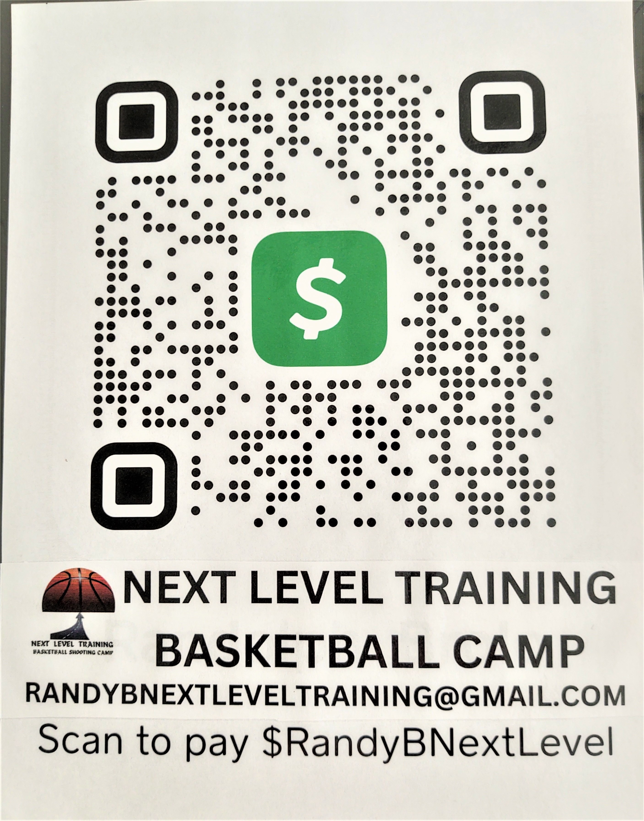
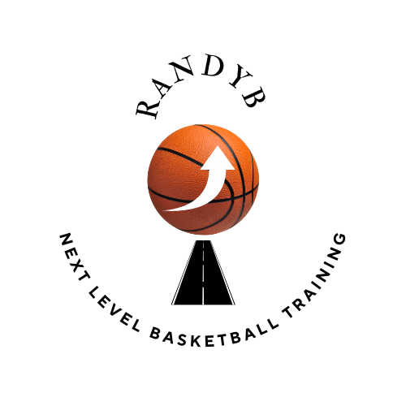

PARTICIPANT REGISTRATION

Holly Hills Elementary School Westampton NJ

NAME OF PARTICIPANT_______________________________________________________

GENDER___________________

AGE _______________________

E-MAIL ______________________________________________________________

GUARDIANS PHONE ________________________________________________

MAILING ADDRESS _____________________________________________________________
__________________________________________________________________________________

T- SHIRT SIZE_____________ (MUST BE ENTERED BY JUNE 1)

NAME OF SCHOOL PARTICIPANT ATTENDS _______________________

MEDICAL CONCERNS_______________________________________________

GOALS FOR PARTICIPANT__________________________________________

PAYMENT $75.00 mon-fri 9a-3p
https://cash.app/$RandyBNextLevel

DUE DATE DAY 1 OF NEXT LEVEL TRAINING BASKETBALL CAMP

CASH – MONEY ORDER - CASH APP https://cash.app/$RandyBNextLevel

GUARDIAN SIGNATURE_______________________________________________________

DATE ______________________________
EMERGENCY CONTACT _______________________________________________________

PARTICIPANT REGISTRATION WAIVER

CANCELLATION POLICY
There is no refund policy on sessions purchased. Package sessions must be used consecutively and within the time specified. Next Level Training reserves the right to cancel an event or program due to insufficient registration with full refunds and notification.

PHOTO RELEASE
Photographs and videos may be taken at any time on behalf NEXT LEVEL TRAINING Your irrevocable consent to be recorded, your irrevocable consent to the use of your participating registered camper recorded by Next Level Training and others acting on behalf for the purpose of advertising and promotion in any media, throughout the world perpetuity, including but not invited to television and the world wide web, and your waiver of any compensation or permission for such use.

MEDICAL RELEASE AND LIABILITY RELEASE
Participation in all sports can be inherently dangerous and it is impossible to ensure safety of all participating individuals. Basketball demands cardiovascular fitness,coordination and agility. Although many risk can be avoided, I understand that not all risk can be and I release Next Level Training from responsibility for any injury that the registered youth might incur during the course of normal play. I agree to also indemnify and hold harmless the volunteers, trainers, coaches, directors, owners of the organization. I further understand that in the event of a medical emergency, Next Level Training will call EMS to render assistance and that I will be financially responsible for any expense.

Guardian Signature _____________________________________________________Date _____________

CAMP CODE OF CONDUCT
Our primary objective is to create positive change in the campers who attend our camp.
Moreover, we want to ensure the safety of our campers at all times and provide healthy,learning atmosphere. To achieve these objectives, we ask that campers conduct themselves in a positive and responsible manner. With that in mind, we created a POSITIVE CODE of CONDUCT amd ask that all campers do their best to adhere to it:
. To think positive and act positive throughtout ypur stay with us.
. To behave with proper etiquette at the facility at all times
. To treat fellow campers and coaches with respect, consideration and kindness they deserve
. To be on time for all camp functions.
. To report any personal problems or concerns to a staff member immediately.
. To report any signs of illness or injury to a staff member immediatel. To stay with the assigned staff member (i.e. coach ) at all times.
. To stay within the camp residence at all times unless given permission by a staff member.
. To respect fellow campers and camp staff by limiting no cell phone use during camp functions.

Any serious violation of camp regulations, such as willful damage to the facility property and/or behavior deemed unsuitable and detrimental to the best interest of the camp, will be grounds for immediate dismissal from camp without refund or voucher.

CANCELLATION POLICY
If you need to cancel for any reason up until 24 hours prior to camp check-in, you will receive a camp credit voucher for tuition fees paid that is good through the following year for NEXT LEVEL TRAINING BASKETBALL CAMP.

COMMUNICATION WITH CAMPERS DURING CAMP
Campers are permitted to call their family and friends during their lunch breaks and after hours, unless otherwise specified by the Camp Director. We do not allow the use of cell phones during training sessions. If you need to reach your child for an urgent matter, please email the director at RandyBnextleveltraining@gmail.com or come into the facility and contact the Camp Director.

PACKING LIST
Below is a suggested list of clothes,equipment and personal items. NEXT LEVEL TRAINING BASKETBALL CAMP IS NOT RESPONSIBLE FOR LOST OR STOLEN ARTICLES OR MONEY.
.Athletic, on – court clothing
.Athletic shoes
.WATER BOTTLE
.Packed lunch and snacks
.Small gym / backpack

